**Industrial Internship Report on**

**”Online Student Mangement System”**

**Prepared by**

**[Subashree.S]**

|  |
| --- |
| *Executive Summary* |
| This report provides details of the Industrial Internship provided by upskill Campus and The IoT Academy in collaboration with Industrial Partner UniConverge Technologies Pvt Ltd (UCT).  This internship was focused on a project/problem statement provided by UCT. We had to finish the project including the report in 6 weeks’ time.  My project was (online student management system)  This internship gave me a very good opportunity to get exposure to Industrial problems and design/implement solution for that. It was an overall great experience to have this internship. |

**TABLE OF CONTENTS**

1 Preface 4

2 Introduction 5

2.1 About UniConverge Technologies Pvt Ltd 5

2.2 About upskill Campus 8

2.3 Objective 9

2.4 Reference 9

2.5 Glossary 10

3 Problem Statement 11

4 Existing and Proposed solution 12

5 Proposed Design/ Model 13

5.1 High Level Diagram (if applicable) 13

5.2 Low Level Diagram (if applicable) 14

6 Performance Test 14

6.1 Test Plan/ Test Cases 14

6.2 Test Procedure 14

6.3 Performance Outcome 15

7 My learnings 16

8 Future work scope 17

# Preface

The Online Student Management System is a full stack web application developed to manage student records efficiently in an educational institution. The system allows administrators to add, update, view, and delete student details through a secure and user-friendly web interface.

This project demonstrates the complete flow of a full stack application, including front-end design, back-end processing, database integration, and CRUD operations.

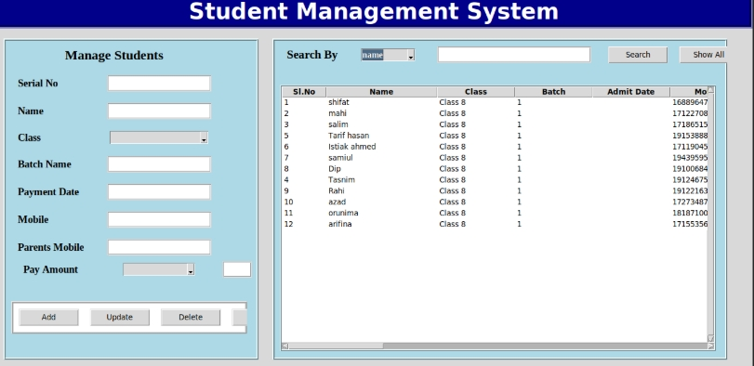

# Introduction

## About UniConverge Technologies Pvt Ltd

A company established in 2013 and working in Digital Transformation domain and providing Industrial solutions with prime focus on sustainability and RoI.

For developing its products and solutions it is leveraging various**Cutting Edge Technologies e.g. Internet of Things (IoT), Cyber Security, Cloud computing (AWS, Azure), Machine Learning, Communication Technologies (4G/5G/LoRaWAN), Java Full Stack, Python, Front end**etc.



1. UCT IoT Platform **(****)**

**UCT Insight** is an IOT platform designed for quick deployment of IOT applications on the same time providing valuable “insight” for your process/business. It has been built in Java for backend and ReactJS for Front end. It has support for MySQL and various NoSql Databases.

* It enables device connectivity via industry standard IoT protocols - MQTT, CoAP, HTTP, Modbus TCP, OPC UA
* It supports both cloud and on-premises deployments.

It has features to  
• Build Your own dashboard  
• Analytics and Reporting  
• Alert and Notification  
• Integration with third party application(Power BI, SAP, ERP)  
• Rule Engine





1. **Smart Factory Platform (****)**

Factory watch is a platform for smart factory needs.

It provides Users/ Factory

* with a scalable solution for their Production and asset monitoring
* OEE and predictive maintenance solution scaling up to digital twin for your assets.
* to unleased the true potential of the data that their machines are generating and helps to identify the KPIs and also improve them.
* A modular architecture that allows users to choose the service that they what to start and then can scale to more complex solutions as per their demands.

Its unique SaaS model helps users to save time, cost and money.

 

1.  based Solution

UCT is one of the early adopters of LoRAWAN teschnology and providing solution in Agritech, Smart cities, Industrial Monitoring, Smart Street Light, Smart Water/ Gas/ Electricity metering solutions etc.

1. Predictive Maintenance

UCT is providing Industrial Machine health monitoring and Predictive maintenance solution leveraging Embedded system, Industrial IoT and Machine Learning Technologies by finding Remaining useful life time of various Machines used in production process.



## About upskill Campus (USC)

upskill Campus along with The IoT Academy and in association with Uniconverge technologies has facilitated the smooth execution of the complete internship process.

USC is a career development platform that delivers **personalized executive coaching** in a more affordable, scalable and measurable way.







Seeing need of upskilling in self paced manner along-with additional support services e.g. Internship, projects, interaction with Industry experts, Career growth Services

upSkill Campus aiming to upskill 1 million learners in next 5 year

<https://www.upskillcampus.com/>

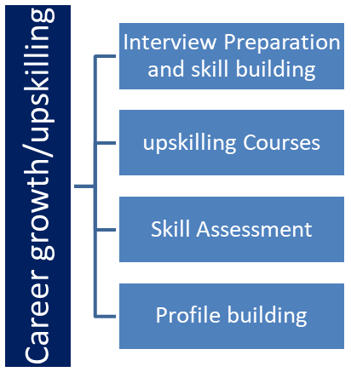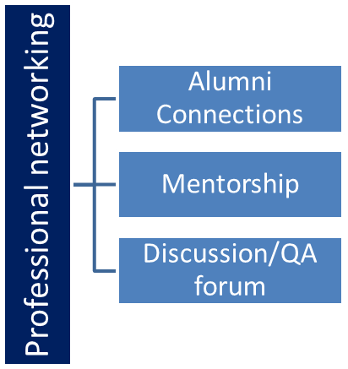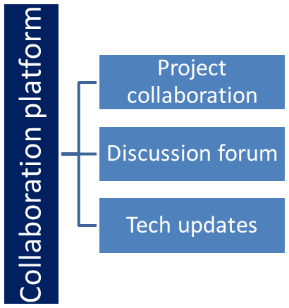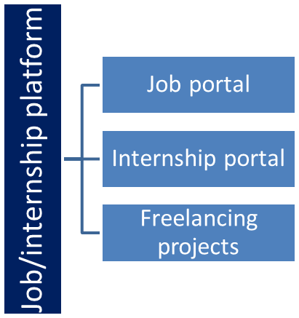

## The IoT Academy

The IoT academy is EdTech Division of UCT that is running long executive certification programs in collaboration with EICT Academy, IITK, IITR and IITG in multiple domains.

## Objectives of this Internship program

The objective for this internship program was to

 ☛ get practical experience of working in the industry.

 ☛ to solve real world problems.

 ☛ to have improved job prospects.

 ☛ to have Improved understanding of our field and its applications.

 ☛ to have Personal growth like better communication and problem solving.

**3. Problem Statement**

In the assigned problem statement

Educational institutions often manage student data manually or using basic systems, which can lead to data redundancy, errors, and difficulty in accessing records.

The problem is to develop a web-based system that efficiently manages student information, reduces manual effort, and ensures secure and quick access to data.

# Existing and Proposed solution

* Manual record maintenance
* Excel-based systems
* Lack of centralized data storage
* Time-consuming data retrieval

The proposed solution is a Full Stack Web Application that:

* Stores student data in a centralized database
* Provides role-based access
* Allows real-time data operations
* Improves efficiency and accuracy

## Code submission (Github link)

https://github.com/subashreeseetharaman/upskill_final_subashree.git

## Report submission (Github link) :

# Proposed Design/ Model

## High Level Design

## User Interface (Browser)

## Application Server

## Database Server

## Low Level Design

## 5.1 High Level Diagram (if applicable)

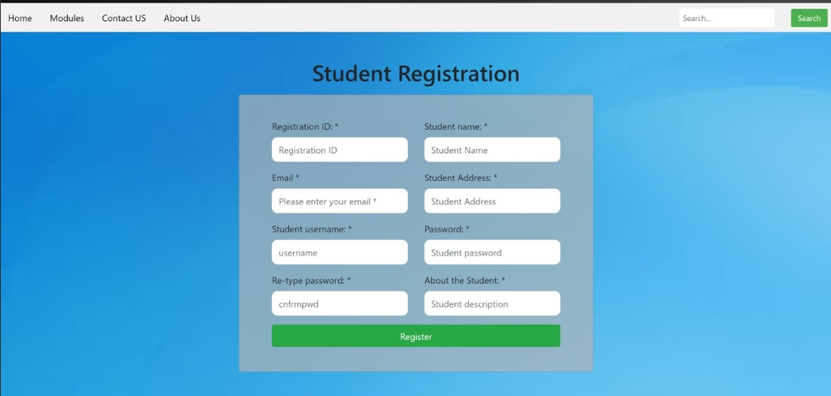

Figure 1: HIGH LEVEL DIAGRAM OF THE SYSTEM

## 

## Low Level Diagram (if applicable)

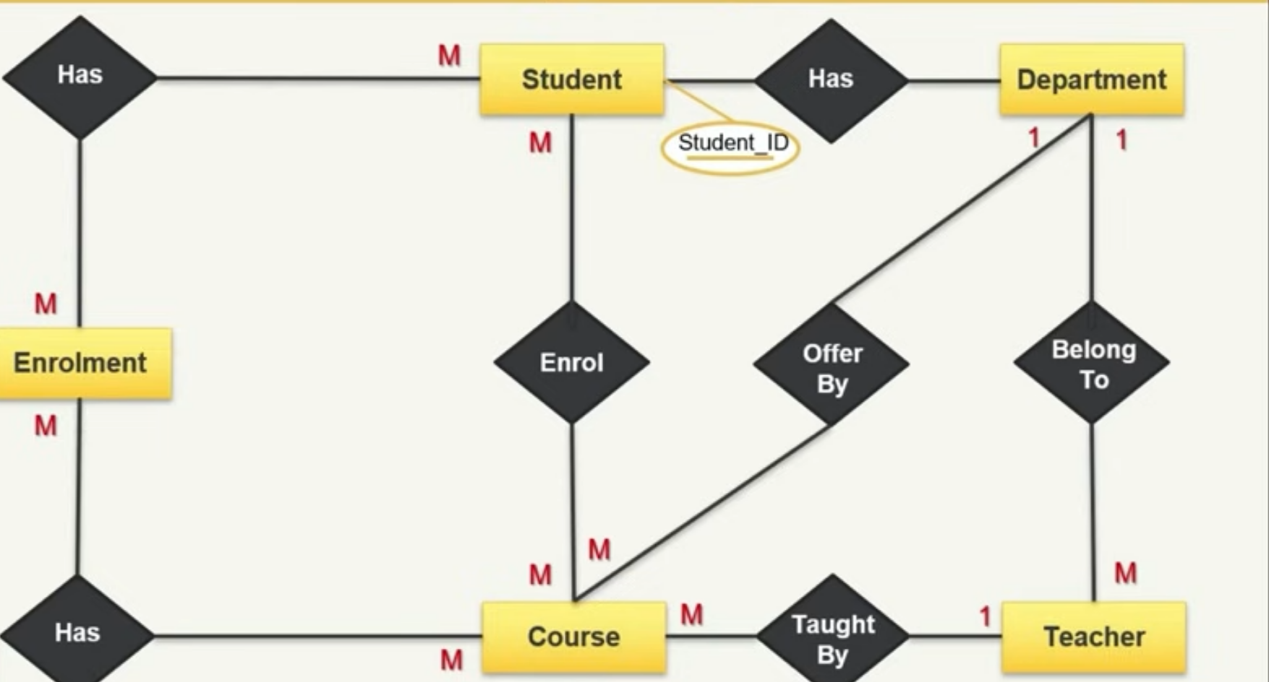

# Performance Test

Constraints Identified:

* Response time
* Data accuracy
* Concurrent user handling

Test Outcome:

* Fast response time
* Accurate data storage and retrieval
* Stable performance for multiple users

**6.1 Test Cases**

1.Login Test

* Valid user credentials allow successful login.

2.Invalid Login Test

* Invalid credentials display an error message.

3.Add Student Test

* New student details are added successfully.

4.View Records Test

* Student records are displayed correctly.

5.Update Record Test

* Existing student details are updated.

6.Delete Record Test

* Selected student record is removed.

7.Database Test

* Data is stored and retrieved correctly.

8.Logout Test

* User logs out successfully.

**6.2 Test Procedure**

* Launch the web application
* Login using valid credentials
* Perform CRUD operations on student records
* Verify data updates in the database
* Logout from the application

**6.3 Performance Outcome**

* Application responds within acceptable time
* Data accuracy maintained
* No data loss during operations
* Stable performance for multiple requests

**7. My learnings**

* Practical knowledge of full stack development
* Understanding client-server architecture
* Database design and integration
* Improved debugging and problem-solving skills
* Experience in real-world application development

# Future work scope

* Add admin and student role separation
* Implement cloud deployment
* Enhance UI with React
* Add reporting and analytics features